**MONGO DB**

MongoDB is a noSQL DB. It is not structured DB system. It doesn’t hold data in the form of tables(rows/columns)

**Installation**

Before you start using MongoDB in Java programs, you need to make sure that you have MongoDB CLIENT and Java set up on the machine. Now, let us check how to set up MongoDB CLIENT.

* You need to download the jar **mongodb-driver-3.11.2.jar and its dependency mongodb-driver-core-3.11.2.jar.**. Make sure to download the latest release of these jar files.
* You need to include the downloaded jar files into your classpath.

## How to Download and Install MongoDB Compass

## To download MongoDB Compass, you can use your preferred web browser, and Open the [https://www.mongodb.com/download-center/compass?jmp=docs page](https://www.mongodb.com/download-center/compass?jmp=docs).

## Select the installer and version you prefer.

## Finally, Click on the download button.

## Click on the installer file after the download is complete.

## Follow the pop-ups to install MongoDB Compass GUI.

## Once it is installed, it launches and ask to configure privacy settings and specify update preference.

## MongoDB Compass

**MongoDB insert documents**

Insert a document into a collection named student. This operation will automatically create a collection if the collection does not currently exist.

db.collection.insert() 🡪 method used to add or insert new documents

Input

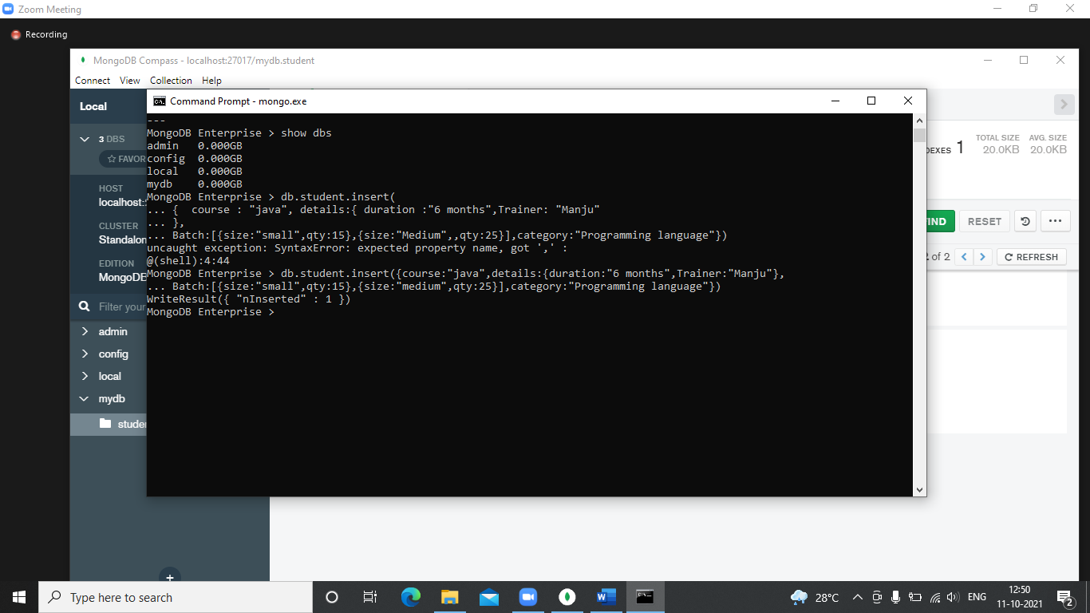

In this **nInserted** field specifies the number of documents inserted.

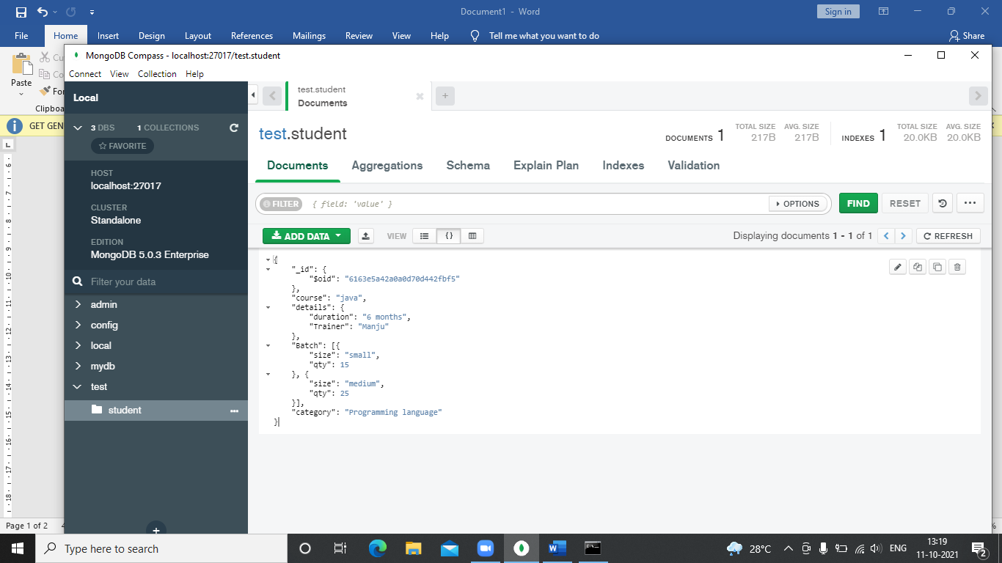

Output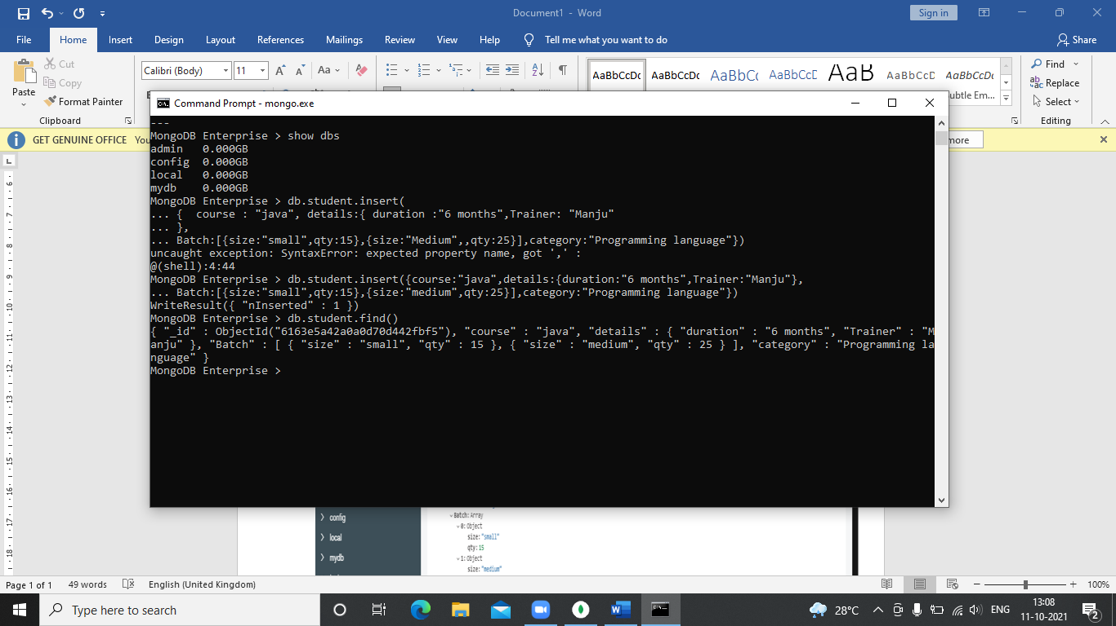

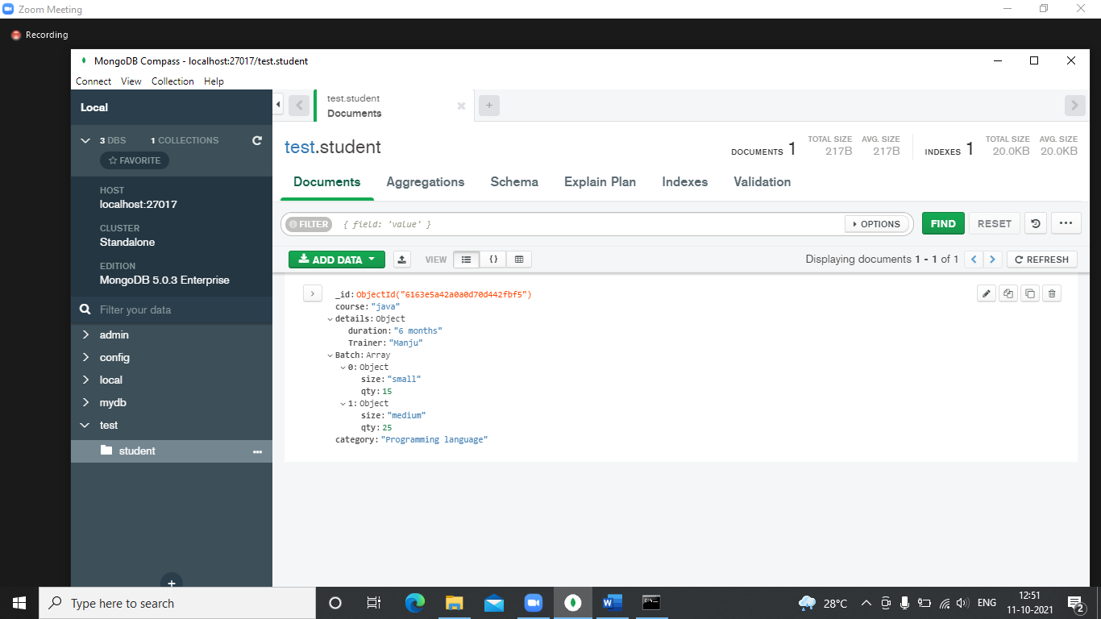

# **Update documents**

In MongoDB, update() method is used to update or modify the existing documents of a collection.

1. SYNTAX 🡪 db.COLLECTION_NAME.**update**(SELECTIOIN_CRITERIA, UPDATED_DATA)

**INPUT**

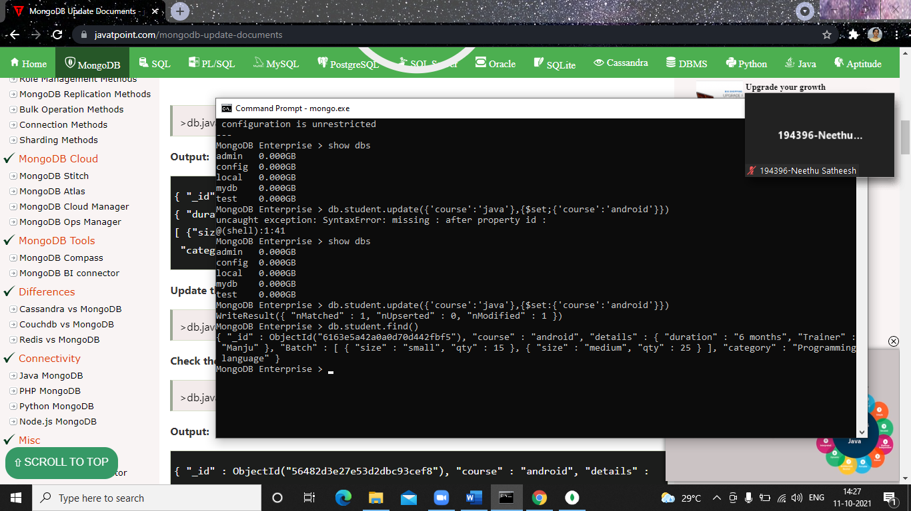

**OUTPUT**



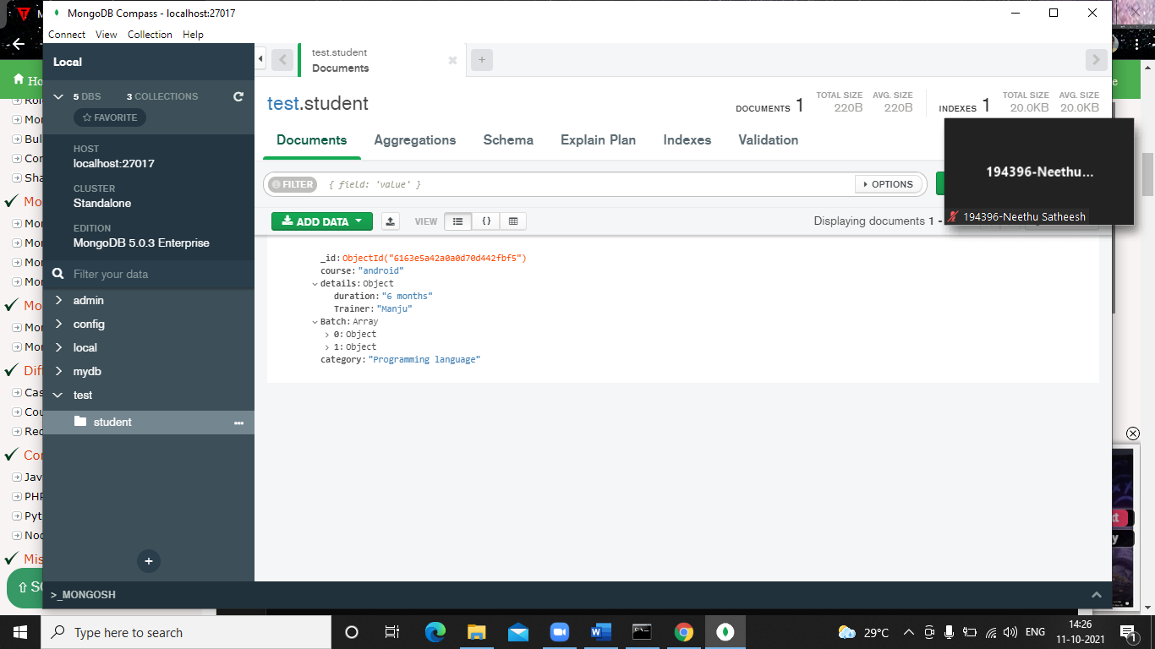

# **Delete documents**

db.collection.remove() 🡪 method is used to delete documents from a collection.

The remove() method works on two parameters.

**1. Deletion criteria:** With the use of its syntax you can remove the documents from the collection.

**2. JustOne:** It removes only one document when set to true or 1.

db.javatpoint.remove( { type : "programming language" }, 1 )



**Query documents**

The db.collection.find() method reads operations in mongoDB shell and retrieves documents containing all their fields.

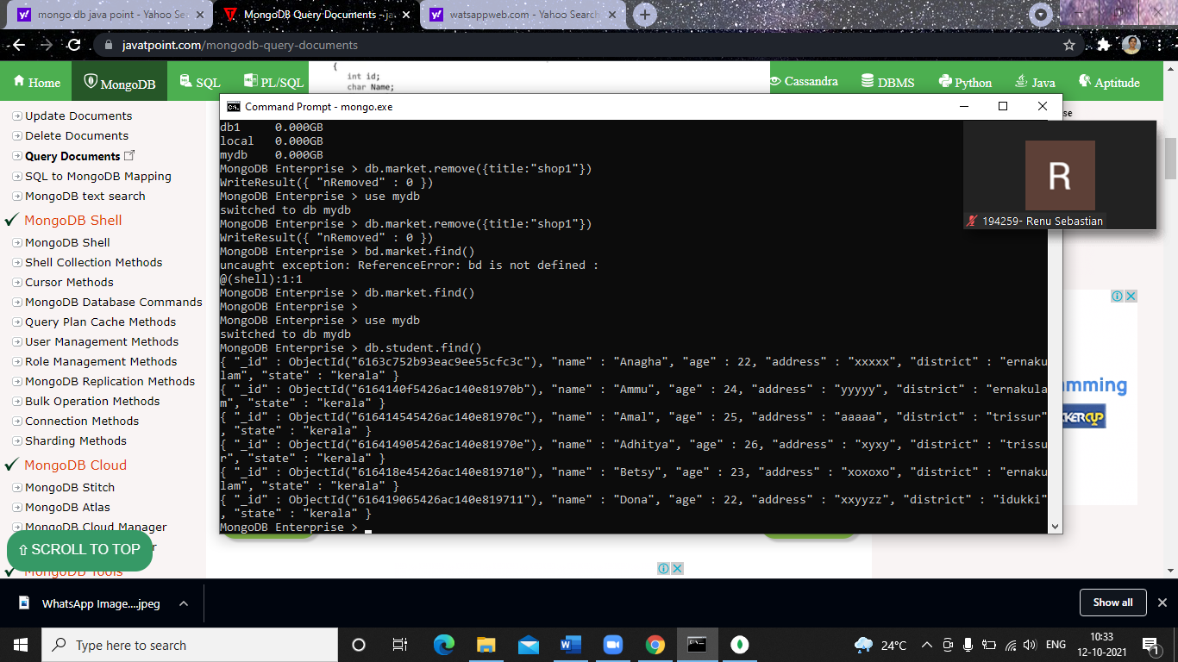

**Aggregation functions**

Aggregation operations process data records and return computed results. Aggregation operations group values from multiple documents together, and can perform a variety of operations on the grouped data to return a single result.

**$MATCH()**

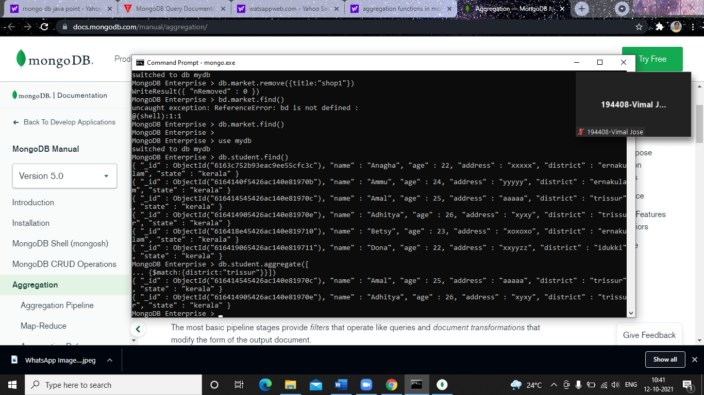

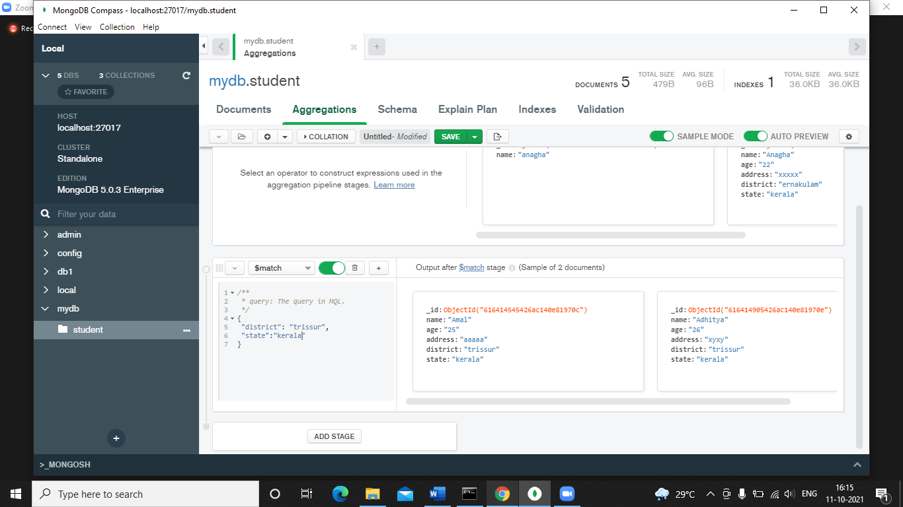

**$GROUP()**

